Endazhi-Nitaawiging
School Board Policies & Procedures Manual
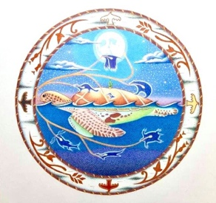
102 – Equal Education Opportunity

- PURPOSE

The purpose of this policy is to ensure that equal educational opportunity is provided for all students of Endazhi-Nitaawiging.

GENERAL STATEMENT OF POLICY

  - The policy of Endazhi-Nitaawiging is to provide equal educational opportunity for all students. Endazhi-Nitaawiging does not unlawfully discriminate on the basis of race, color, creed, religion, national origin, sex, marital status, parental status, status with regard to public assistance, disability, sexual orientation, including gender identity and expression, or age. Endazhi-Nitaawiging also makes reasonable accommodations for disabled students.

  - Endazhi-Nitaawiging prohibits the harassment of any individual for any of the categories listed above. For information about the types of conduct that constitute violation of Endazhi-Nitaawiging’s policy on harassment and violence and Endazhi-Nitaawiging’s procedures for addressing such complaints, refer to Endazhi-Nitaawiging’s policy on harassment and violence.

  - This policy applies to all areas of education including academics, coursework, co-curricular and extracurricular activities, or other rights or privileges of enrollment.

  - Every Executive Director employee shall be responsible for complying with this policy conscientiously.

  - Any student, parent, or guardian having a question regarding this policy should discuss it with the appropriate Executive Director official as provided by policy. In the absence of a specific designee, an inquiry or a complaint should be referred to the Executive Director.

Legal References: Minn. Stat. § 121A.03, Subd. 2 (Sexual, Religious, and Racial Harassment and Violence Policy)
Minn. Stat. Ch. 363A (Minnesota Human Rights Act)
20 U.S.C. § 1681 et seq. (Title IX of the Education Amendments of 1972) 42 U.S.C. § 12101 et seq. (Americans with Disabilities Act)

Cross References: MSBA/MASA Model Policy 402 (Disability Nondiscrimination) MSBA/MASA Model Policy 413 (Harassment and Violence) MSBA/MASA Model Policy 521 (Student Disability Nondiscrimination)
MSBA/MASA Model Policy 522 (Student Sex Nondiscrimination)

Adopted: July 27th, 2022

